**REPORT**

ON

**Traffic Intensity Calculator**



SUBMITTED

TO

**VISHWAKARMA INSTITUTE OF INFORMATION TECHNOLOGY, PUNE**

**For the PBL of Digital Electronics**

IN

**DEPARTMENT OF ELECTRONICS AND TELECOMMUNICATION**

**AY 2023-24**

**Semester II**

BY

|  |  |  |  |  |
| --- | --- | --- | --- | --- |
| **P. R. No.​**  **​** | **Roll No.​**  **​** | **Name of Student​**  **​** | **Mobile No.​**  **​** | **VIIT Email ID​**  **​** |
| 22311251​ | 101145​ | Tanushri Chetan Rajput​ | 8446029351​ | tanushri.22311251@viit.ac.in​ |
| 22311496​ | 101149​ | Atharva Rajendra Joshi​ | 9527043551​ | atharva.22311496@viit.ac.in​ |
| 22311517​ | 101153​ | Revati Tushar Aute ​ | 8208092760​ | revati.22311517@viit.ac.in​ |
| 22311608​ | 101158 ​ | Manas Girish Kulkarni ​ | 7972470825​ | manas.22311608@viit.ac.in​ |

**Class: F. Y. B. Tech. Division: A Batch: A3**

**Batch Incharge**

**Mrs. Rupa Kawchale**

**Circuit Diagram**

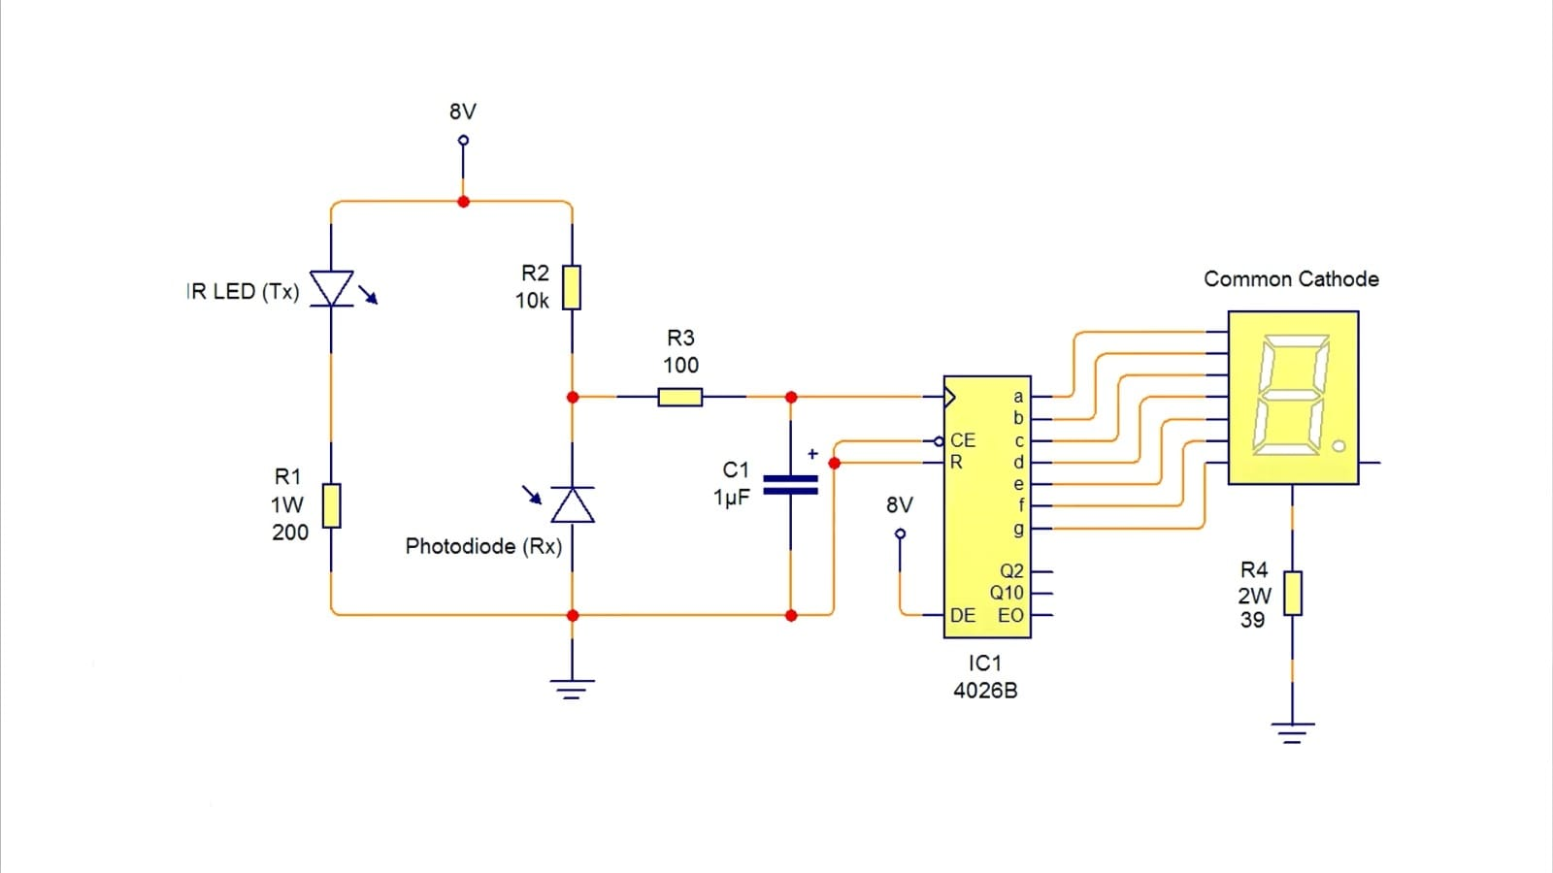

**CD4026 Pinout Diagram**

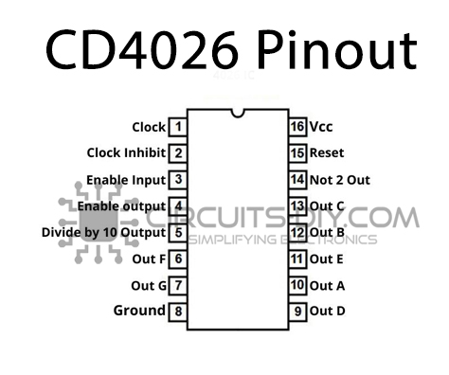

**Images of Model**

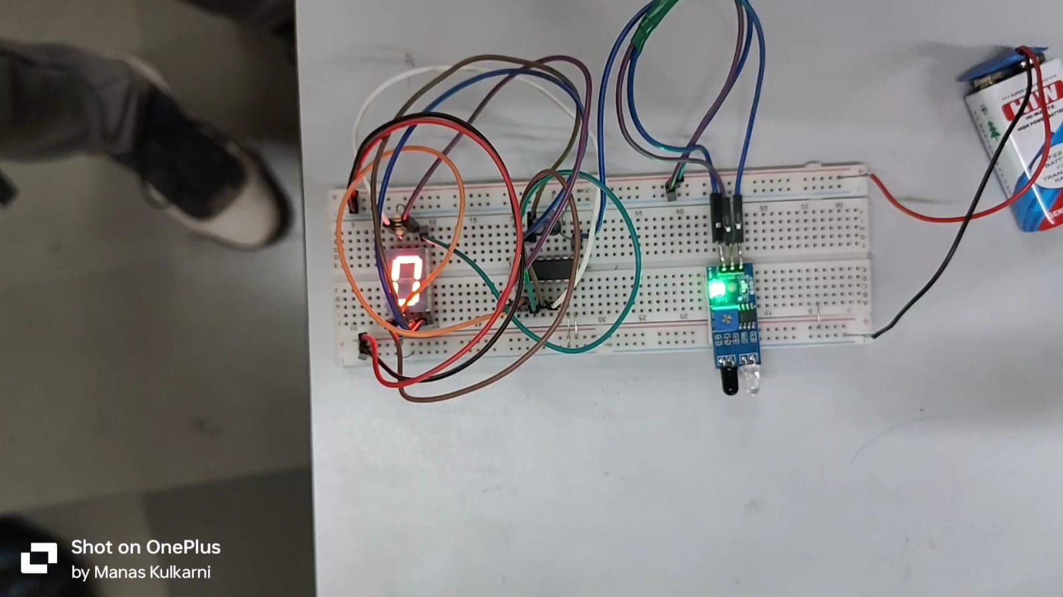

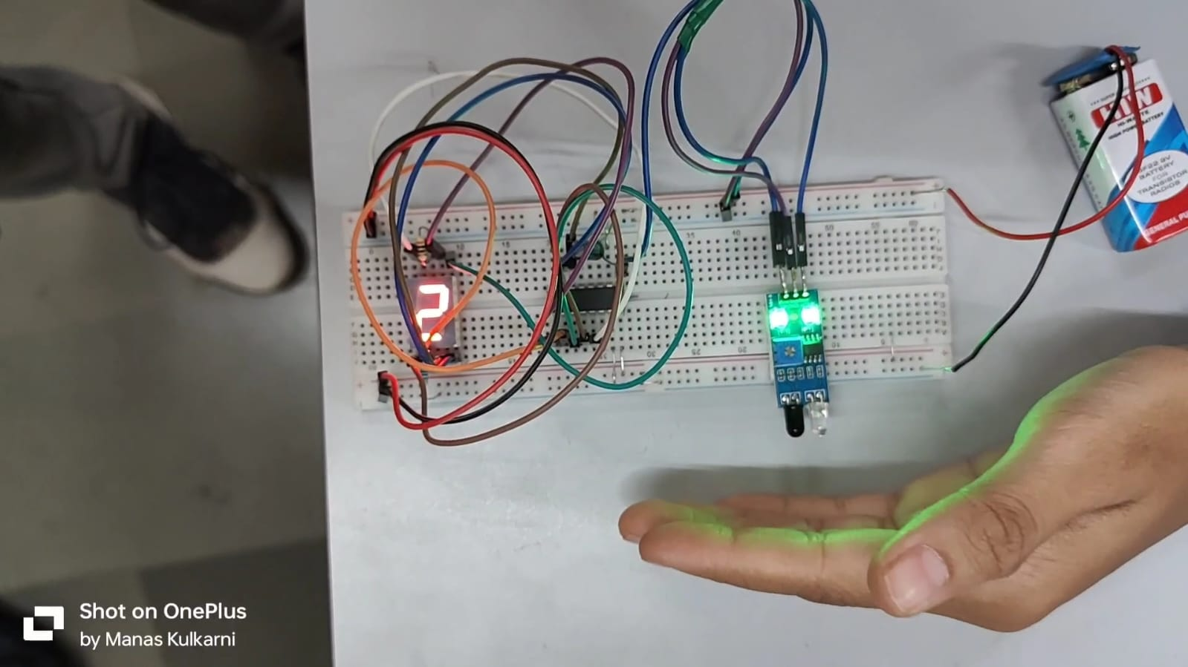

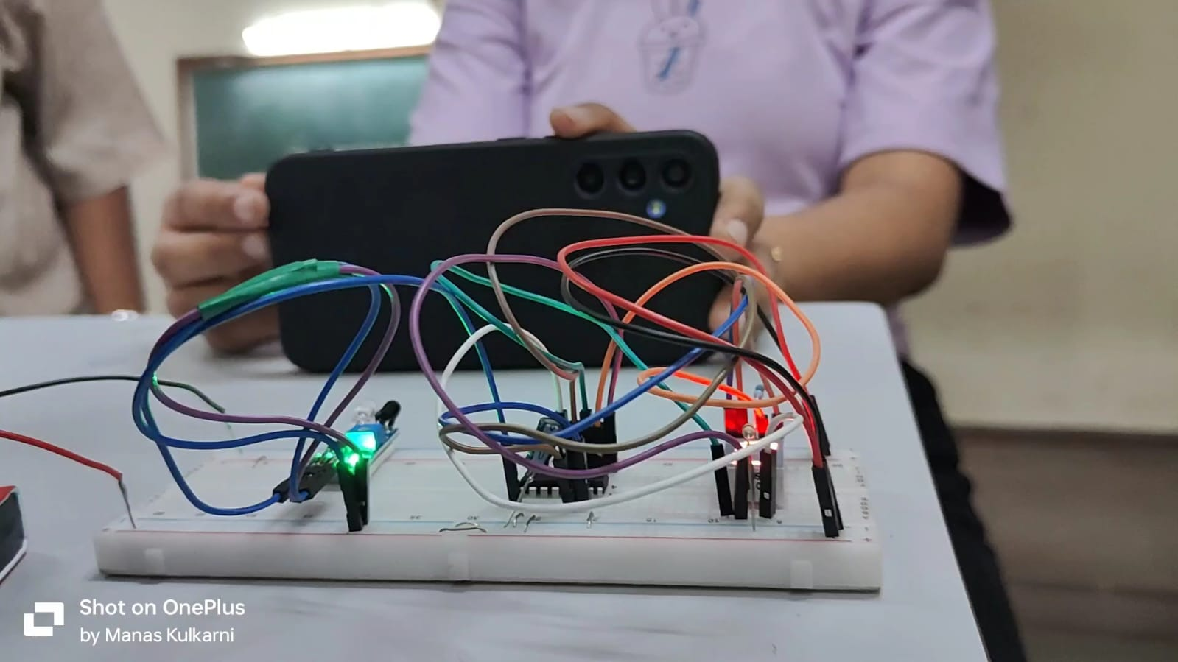

**Code (Python – Tkinter)**

import tkinter as tk

def calculate_traffic_intensity():

    num_vehicles = int(entry_vehicles.get())

    time_seconds = int(entry_time.get())

    intensity = num_vehicles / time_seconds

    result_label.config(text="Traffic intensity: {:.2f}".format(intensity))

# Create main window

root = tk.Tk()

root.title("Traffic Intensity Calculator")

# Create input fields

label_vehicles = tk.Label(root, text="Number of vehicles:")

label_vehicles.grid(row=0, column=0, padx=10, pady=5)

entry_vehicles = tk.Entry(root)

entry_vehicles.grid(row=0, column=1, padx=10, pady=5)

label_time = tk.Label(root, text="Time in seconds:")

label_time.grid(row=1, column=0, padx=10, pady=5)

entry_time = tk.Entry(root)

entry_time.grid(row=1, column=1, padx=10, pady=5)

# Create calculate button

calculate_button = tk.Button(root, text="Calculate", command=calculate_traffic_intensity)

calculate_button.grid(row=2, column=0, columnspan=2, pady=10)

# Create result label

result_label = tk.Label(root, text="")

result_label.grid(row=3, column=0, columnspan=2)

root.mainloop()

**Output**

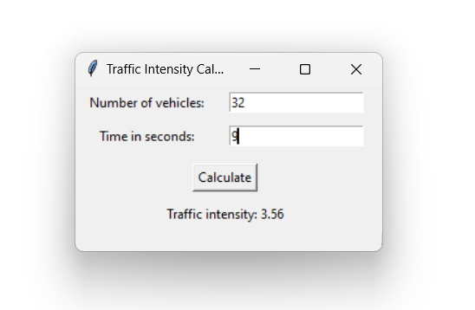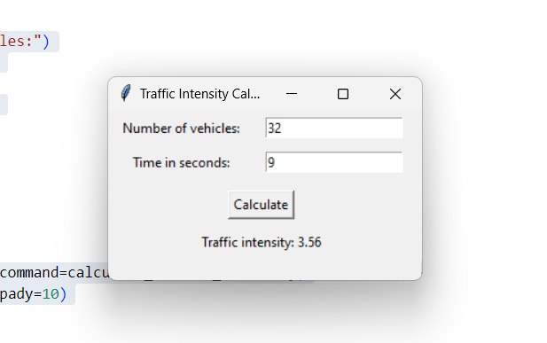

**Working of Project**

**CD4026 IC:**

* The CD4026 is a **CMOS counter IC** with a built-in **7-segment output driver**.
* It is capable of driving **common cathode LED displays** directly.
* The IC has a **5-stage Johnson decade counter** and an output decoder.
* The output decoder transforms the Johnson code into a **7-segment decoded output**.
* The IC increments its count each time it receives a **high clock pulse**.
* In our project, this pulse is generated when a vehicle interrupts the infrared beam of the IR module.
* The **clock inhibit pin (pin 2)** is held low (ground/0V) so that the clock signals can be sent to the IC.
* The **Enable Input pin (pin 3)** is made high (+5V) to activate the output pins.
* The IC can work from **3V to 15V**, but we typically power it with +9V to the Vdd/Vcc pin.
* The **Ground/Vss pin** is connected to the ground.
* The **7-segment pins** will increment the count by one number each time when the clock pin (pin 1) is made high.

**Python Tkinter:**

* We have used Python Tkinter to create a **simple interface** that displays the current count of vehicles from the CD4026.
* By dividing the total count of vehicles by the elapsed time (in seconds), we calculate the **vehicle intensity** (vehicles per second).
* This value is then displayed on the Tkinter interface.

**Project Integration:**

* We have developed a system that not only counts vehicles but also calculates and displays vehicle intensity.
* This is achieved by integrating the hardware components (CD4026 IC and IR module) with the Python Tkinter interface.
* This combination of hardware and software components makes our project a robust and efficient solution for vehicle counting and intensity calculation.